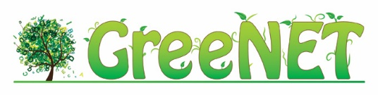 | 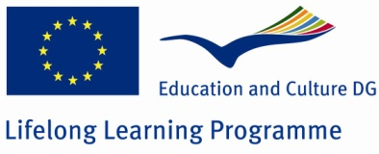
DELIVERABLE

Project Acronym: | GreeNET
Grant Agreement number: | 527891
Project Title: | Environmental Education through Enquiry and Technology

D4.4 – European Transnational Workshop

Revision: [Final]

Authors:
Vassiliki Markaki (GRNET)
Katerina Galani (GRNET)
Project co-funded by the European Commission within the LLP Comenius Network Programme
Dissemination Level
P | Public
C | Confidential, only for members of the consortium and the Commission Services | Χ
Katerina Papakonstantinou (GRNET)

Revision history:
Revision | Date | Author | Organization | Description
0.1 | 21/11/14 | Vassiliki Markaki | EA | First draft ToC
0.2 | 28/11/14 | Katerina Galani | GRNET | Deliverable first version
0.3 | 27/2/15 | Katerina Papakonstantinou | GRNET | Revisions
0.4 | 13/3/15 | Katerina Galani | GRNET | Final version

Statement of originality:
This deliverable contains original unpublished work except where clearly indicated otherwise. Acknowledgement of previously published material and of the work of others has been made through appropriate citation, quotation or both.

This project has been funded with the support of Lifelong Learning program of the European Union. This publication reflects the views only of the author, and the Commission cannot be held responsible for any use which may be made of the information contained therein.

Executive Summary
The European Transnational Workshop 2014 was organised and facilitated by Ecoinstitut, Ellinogermaniki Agogi and GRNET on Thursday, November 13th, 2014 at the CESIRE offices in Barcelona, Spain. The European Transnational Workshop was organized within the context of the GreeNET European Project (http://greenet.ea.gr/) and aimed at bringing together school teachers, educators and policy makers of the environmental education sector with the objective to try and solve some of the most critical problems of the environmental education through close examination of their own good practices, and based on hands-on innovative activities.

Table of contents
Executive Summary 3
Table of contents 5
Table of Tables 5
Table of Figures 5
1 Introduction 7
1.1 Scope 7
1.2 Audience 7
1.3 Definitions 7
1.4 Structure 7
2 The context of European Transnational Workshop 8
3 Agenda 9
4 Objectives 10
5 Approach 11
5.1 Harvest Requirements 13
5.2 Plant Seeds 16
5.3 Cultivate Ideas 17
5.4 Blossom & Thrive 18
6 Conclusions 20
7 Annex I : List of Participants 21

Table of Tables
Table 3.1 Agenda 9
Table 7.1 List of Participants 22

Table of Figures
Figure 2.1 Green Ideas Concept 8
Figure 5.1 Challenge 1 13
Figure 5.2 Challenge 2 13
Figure 5.3 Inspirational speech on entrepreneurial best practices for students. 14
Figure 5.4 Inspirational speech on issues around educational outdoors activities 14
Figure 5.5 Inspirational speech on teachers’ training 14
Figure 5.6 Harvest Requirements (ii) 15
Figure 5.7 Harvest Requirements (i) 15
Figure 5.8 Harvest Requirements (iv) 15
Figure 5.9 Harvest Requirements (iii) 15
Figure 5.10 Plant Seeds 16
Figure 5.11 Cultivate Ideas (i) 17
Figure 5.12 Cultivate Ideas (ii) 17
Figure 5.13 Cultivate Ideas (iii) 17
Figure 5.14 Cultivate Ideas (iv) 17
Figure 5.15 Blossom & Thrive Phase (i) 18
Figure 5.16 Blossom & Thrive Phase (ii) 19

- Introduction
  - Scope
This deliverable presents the events of the European Transnational Workshop, which was held in Barcelona as an Implementation Activity of WP4.
  - Audience
This is a public document, addressed to the GreeNET Consortium, the European Commission as well as the participants of the workshop and any other relevant stakeholder who wishes to benefit from the results.
  - Definitions
ETW: European Transnational Workshop
ICT: Information & Communications Technology
  - Structure
Chapter 1: contains an overview of this document, providing its Scope, Audience, and Structure.
Chapter 2: describes the context of the ETW.
Chapter 3: provides an Agenda of the event.
Chapter 4: describes the objectives set for this event.
Chapter 5: describes the approach adopted for this event.
Chapter 6: summarizes the contents of the ETW and provides future recommendations.
Annex I: provides a list of the workshop participants.

The context of European Transnational Workshop
The ETW was based on the design thinking approach of Green Ideas (http://greenideasproject.org). Green Ideas are interactive and engaging workshops that explore ways in which green innovation may be empowered by education and technology. They are organized in the form of dynamic workshops that use the design-thinking approach to innovate new ideas with actionable next steps. Within Green Ideas, collaboration and ideation happen in stages (harvest requirements, plant seeds, cultivate ideas, blossom & thrive). Throughout the experience, participants engage in activities that accelerate meaningful collaboration.
In the figure below, an overview of the Green Ideas Concept is presented. Starting from the left, the main phases of the Green Ideas approach are shown, from the beginning of each event (“Harvesting Requirements”) to its end (“Blossom & Thrive”). On the second column, each phase of the Green Ideas approach is broken down to its main sub-phases that elaborate on the specific tasks that take place within each phase. In the case of “Develop Idea” & “Present Idea” sub-phases, a series of components of the Green Ideas approach are presented, based on which each event can be customized (Hack/App, Business Idea, 3D-Model, etc.). Finally, on the right part of the figure, the Team-building Activities and Inspiring Speeches are shown, running through the whole course of the event.

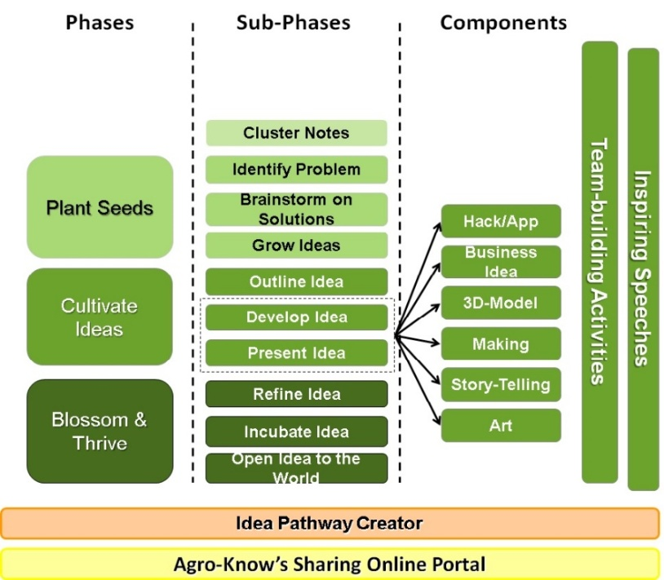
Figure 2.1 Green Ideas Concept

Agenda
European Transnational Workshop | November 13th 2014
Time | Topic
15:30 – 15:45 | Registrations & Welcome Coffee
15:45 – 16:00 | Welcome Session: CESIRE
16:00 – 16:15 | The European Transnational Workshop & its scope & one dynamic to break the ice and make three groups
16:15 – 17:15 | Harvest Requirements  Inspiring Speeches & Interviews (45’)  Sharing Notes & Clustering (15’)
17:15 – 18:00 | Plant Seeds  Identify Problem (10’): The participants revisit the clusters developed during the previous phase, elaborate further on the ideas that inspire them or add new ideas  Brainstorm on solutions (15’): Participants are discussing on possible solutions that can tackle the problem  Grow Ideas (20’): Participants start to formulate mature ideas that will be discussed and voted upon
18:00 – 18:15 | Coffee Break
18:15 – 19:00 | Cultivate Ideas  Develop & Outline the Idea (30’): The participants are asked to create a 3D model depicting their idea and provide a title & a short description for it  Present the Idea (15’ in total // 5’ each presentation): Each of the three groups presents their idea to the rest of the participants
19:00 – 19:45 | Blossom & Thrive  Refine the Idea (10’): Each group revisits and refines their idea based on the collected feedback during the previous phase  Incubate the Idea (20’): Each group develops a detailed business plan for the next year, taking into account the sustainability of their product and its outreach to potential investors/ supporters  Pitch the Idea (15’ in total// 5’ each presentation): Each group is delivering an “elevator pitch” aiming to attract potential interested parties and even investors for their idea!
19:45 – 20:15 | Share Knowledge, Draw Conclusions, Evaluate

Table 3.1 Agenda

Objectives
The goal of closing the second year of the project with this workshop was addressing 1) teachers 2) project partners 3) project associated partners. In addition, this workshop involved students as they are the concrete end users of the Best Practices produced by the GreeNET project. The result of this workshop were two Best Practices for environmental awareness/education with connection to the world of work. These Best Practices were the joint effort of the participants to share their experience and the problems they face in their daily work and come up with innovative ways to solve them.
Green Ideas are interactive and engaging workshops, based on the principles of design thinking and Inquiry Based Learning (IBSE) that aim at spurring creativity and fostering innovation on environmental issues. Another aim of this specific event was to familiarize the participants with design thinking as part of the Best Practices collected by GreeNET. The goal was to guide the participants through the mentality of creating meaningful Best Practices as environmental learning activities, through the process of Green Ideas and in the end actively relate to the principles of IBSE.

Approach
Following the Green Ideas methodology, the workshop developed in four different stages. Through the course of these stages the participants were called to create ideas/ solutions for specific challenges under the guidance of two experienced facilitators. The participants (23 excluding the 4 experts and facilitators) varied from environmental educators, primary and secondary school teachers to entrepreneurship educators, students and policy makers. Two groups were formed in order to increase engagement. The composition of each group’s members was such, as to achieve the best input and optimum result for each challenge. More teachers and policy makers were recruited in the first group, as main stakeholders of providing curricula with new and innovative ways of thinking, which was the main concern of the first challenge. The second group involved the students and less of policy makers as its main goal was to find ways for increasing students’ interest in environmental education.
The Green Ideas workshop developed in four different stages. Through the course of these stages the participants were called to create ideas/ solutions for specific challenges under the guidance of two experienced facilitators. The documentation of the event can be found in the following link:
GreeNET European Transnational Workshop
In the beginning of the event, a specific goal (challenge) related to environmental education was set for the participants to address during the aforementioned phases. Below you may find a detailed description of all the phases that the participants went through in order to come up with the desired outcome, a viable and creative solution for the challenge set to them.

Harvest Requirements
During this phase, the participants draw upon the experience of professionals in environmental education by interviewing them in relation to the goal(s) of the event. Their purpose is to take notes related to the success stories being narrated in front of them and the experiences of the invited guests so that they can use them in the next phases of the event. This phase contains the following sub-phases:
- Interviews: During this phase, an interviewee is introduced to the group that asks him/her questions related to their goal, as well as his/ her background and activities, trying to take advantage of his/her experience in addressing the goal that is given to them,
- Share Notes: Once the interviewee leaves the group, the participants are called to share their notes on a common space, explaining the lessons they took away from the interviewing process,
- Cluster Notes: The participants are asked to revisit the notes that were shared on the wall and cluster them into groups of common themes so that the quantity of notes collected is easier to handle during the next phase.

Plant Seeds
During this phase, the participants revisit their notes, adding new ideas on them, or elaborating more on the ones that inspire them. After building on the ideas generated, the participants formulate concrete ideas that can be then developed further. For this phase to be considered completed, each group of participants has to have one or two ideas that will be then “cultivated” and modelled into a coherent story. This phase contains the following sub-phases:
- Identify Problem: During this part, the participants are asked to revisit the clusters created and select the ones that will guide them in finding solutions to the goals set forth in the beginning. Through this selection, the participants acquire a concrete image of the problem they are trying to solve,
- Brainstorm on Solutions: With the problem well-defined, and the main parameters selected, the participants are now discussing on solutions that can tackle the problem, exploring a variety of alternatives, thinking outside the box and experimenting with non-conventional ideas,
- Grow Ideas: During this part, the participants have a clearer image of the problem and are now starting to formulate mature ideas that will be discussed and voted within the group to delve down into the one that will be the answer of the group to the goal set forth.

Cultivate Ideas
During this phase, the participants have a really specific idea that they want to develop (i.e. cultivate) further. Starting from this idea, they describe it as clearly as possible, identifying a title and a description and outlining its main components, creating in the end, a presentation for it. This phase includes the following sub-phases:
- Outline Idea: The participants are called upon to make their idea explicit. For this purpose, they are asked to provide a title for their project and also a short description that will allow them to start imagining how their idea could be developed further,
- Develop Idea: The way in which the idea will be developed further, varies (as can been seen from the previous diagram, but for the specific Green Ideas event we think that the most compatible one is the 3D Model. In this type of outcome (3D Model), the purpose of the participants is to develop a three dimensional model of their project, showcasing how this would work on a bigger scale,
- Present Idea: In the same sense, the way in which the idea will be presented, differs depending on the way in which the teams will choose to develop it. In the case of the 3D-model, the presentation can involve role-playing.

Blossom & Thrive
During the last phase of the Green Ideas Event, the participants have to prove that their ideas are sustainable and that there is a concrete plan of following them through to real-life implementation. Looking at their developed ideas again, they are now called to come up with a tentative schedule that will guide their deployment in real-life situations. To make the scenario more realistic, each group has to also identify and describe a value proposition behind their idea, identifying their target audience and market that would be willing to finance and support their effort. This phase contains the following sub-phases:
- Refine Idea: Based on the feedback that each group collected during the previous phase, when the idea was presented, the group revisits and refines the idea taking into account all the comments,
- Incubate Idea: Once the idea is complete and revised, the group has to think of it in terms of its sustainability and outreach to potential investors/supporters. To this end, all the aspects of the idea have to be clearly described using business planning templates, market analysis and other tools that might be relevant for the 3D model case,
- Pitch Idea: During the final stage of the Green Ideas Event, the teams have to prepare an “elevator-pitch” that is short, concise and descriptive of their idea, presenting it to the other groups of the event, just as if they were the potential investors, trying to get their idea funded.

Harvest Requirements
The facilitators presented the challenges to be addressed during the session. These challenges were related to the fields of environmental education and entrepreneurship.
- How can we design and effectively implement educational activities that lead to new ways of thinking for environmental education? This has a pedagogical approach for the teachers (their resources, tools, etc.)

- How can we design and effectively implement educational activities that promote the students’ interest in environmental sciences? This has an approach centred on the students (their main worries, motivations, fears, etc.)
Figure 5.1 Challenge 1
Figure 5.2 Challenge 2

In order to aid and inspire the participants through the whole process, two experts in their fields were invited to act as interviewees and provide participants with useful feedback on the challenges. Ms. Katerina Chioteli (professor, University of Ioannina) was assigned to the group that dealt with challenge (i), Ms. Mona Schönfelder (researcher, teachers’ trainer, University of Bayreuth) was assigned to the group that dealt with challenge (ii), while Ms. Vassiliki Kalkani (economics school teacher) provided her valuable input and knowledge about entrepreneurship to both groups. Having completed the interviews, the participants were asked to share the notes they kept on a common space on the wall and discuss them with the rest of the group. More than ten ideas were gathered for each challenge to be used as food for thought in the session to follow.
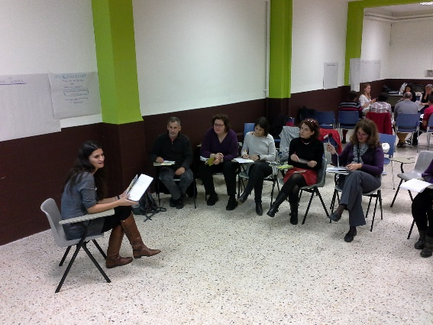
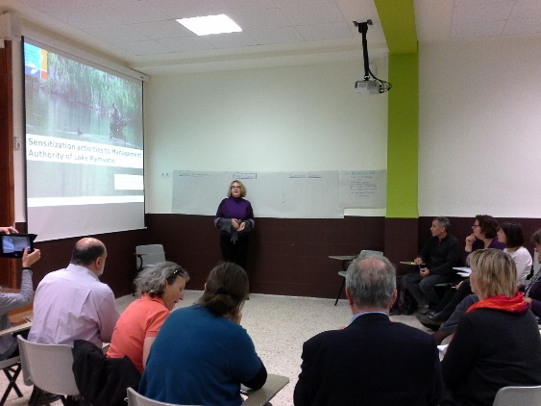
Figure 5.3 Inspirational speech on entrepreneurial best practices for students.
Figure 5.4 Inspirational speech on issues around educational outdoors activities

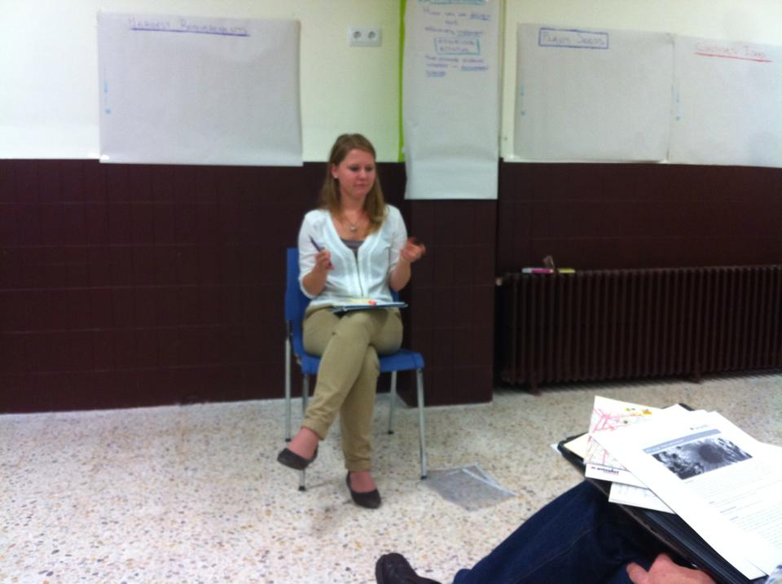
First Group
Figure 5.5 Inspirational speech on teachers’ training
- Use of ICT to solve practical problems (e.g. under-staffed schools, lack of time) that “seem” impossible to solve.
- Combine environmental awareness with entrepreneurship to attract parents to sustainable environmental education that continues after school.
- Need to train parents by raising environmental awareness.
- The impact of environmental activities is not measured
- Need to further train teachers in order to be able to teach any subject in a green way.
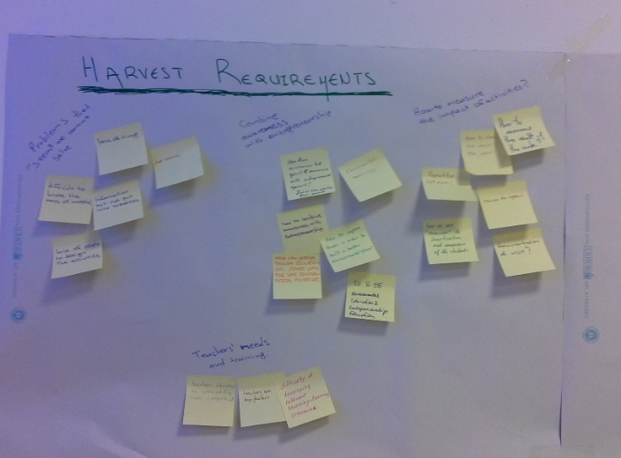
Figure 5.6 Harvest Requirements (ii)
Figure 5.7 Harvest Requirements (i)

Second Group
- Student-centred approach – ask students – teachers need to help students be creative
- Environmental problems are social problems
- In-school learning connected with real life issues is more meaningful
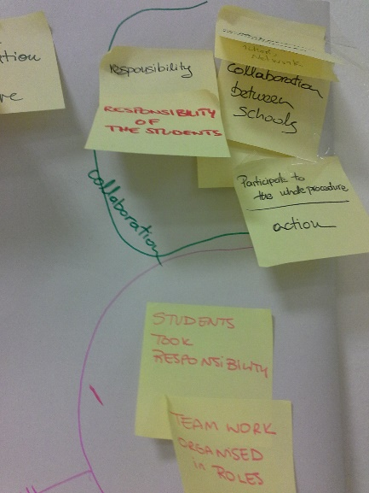
- Entrepreneurial projects are very important and easily connected to environmental issues
Figure 5.8 Harvest Requirements (iv)
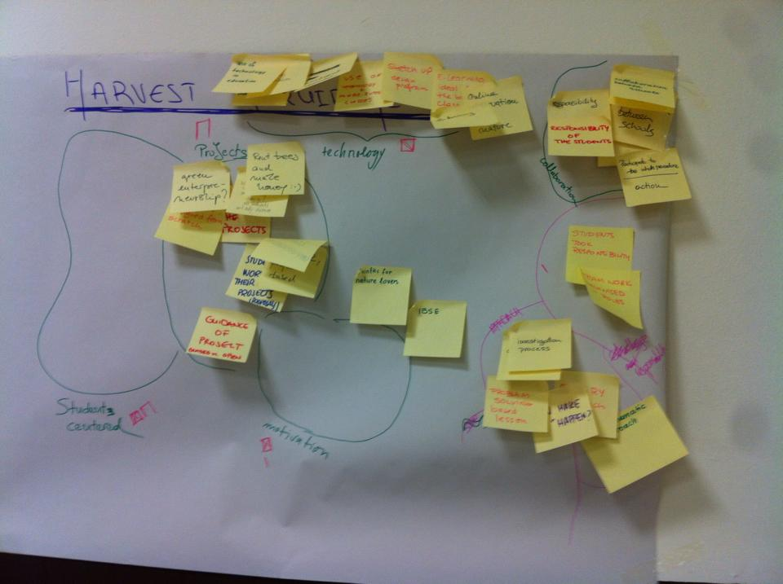
Figure 5.9 Harvest Requirements (iii)

Plant Seeds
In this phase, the participants were asked to take a closer look of the notes collected and started brainstorming in order to connect them and come up with ideas that might solve the problems described by the facilitators in the beginning of the session. Their ultimate aim was to combine crazy with rational ideas that would tackle these problems. To this end, the participants created categories of ideas that used the same approach to solve the challenge (e.g. technology-related, projects in education, students’ centred learning, motivation, in terms of approach etc.). This way the common elements of the several ideas emerged in order to lay the ground for the next session during which the final idea is formed.
First Group
- Joint learning activities involving parents/teachers/students
- Volunteering
- Awards to raise parental and students’ engagement
- Networking with the world of work to increase the parental attention
- Increase scientific training for parents/teachers in order to foster more substantial activities
- Game or challenge element for increased attention and engagement
Second Group
- Contest – finding a green solution for a real problem
- Eco-business day as a yearly thing: start-upers that created a green business/experts on education from universities/parents/school enterprises
- Use innovative actions to motivate students
- On-line game-treasure hunting: questions must be answered through offline, green activities
- Design class – students are asked to design a game with green variables
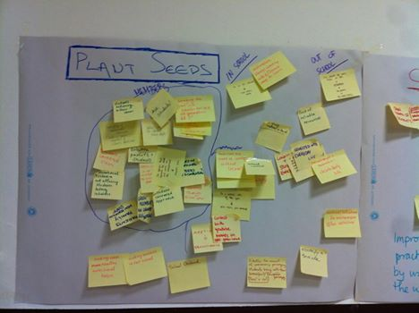

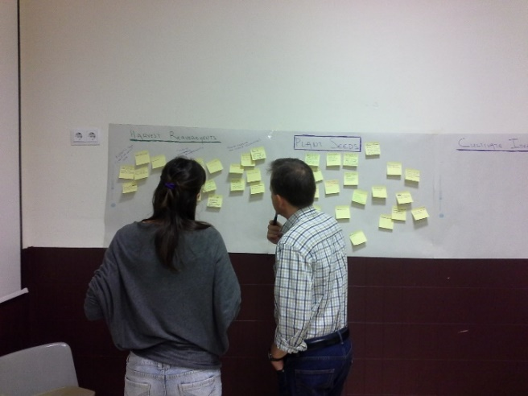
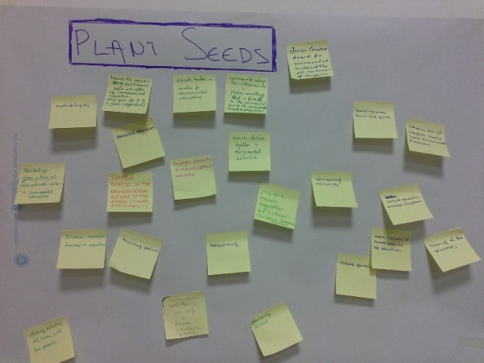
Figure 5.10 Plant Seeds

Cultivate Ideas
During this phase the participants combined the proposed ideas and formed a solution. They were then asked to create a short description of their project and draw its sketch plan. In this process they were able to identify its weaknesses and gaps and gradually form it as a solid product with target audience, development timeline and potential investors.
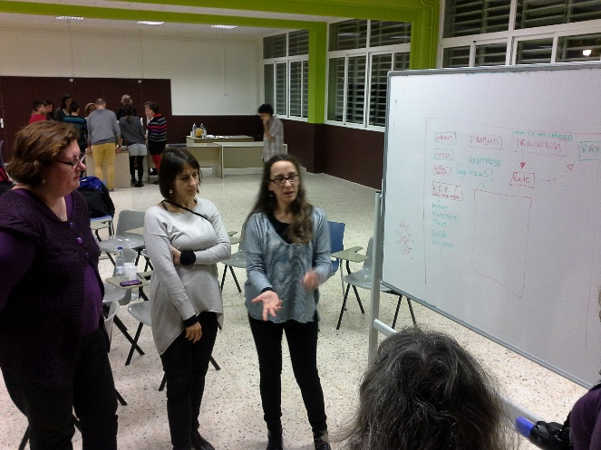
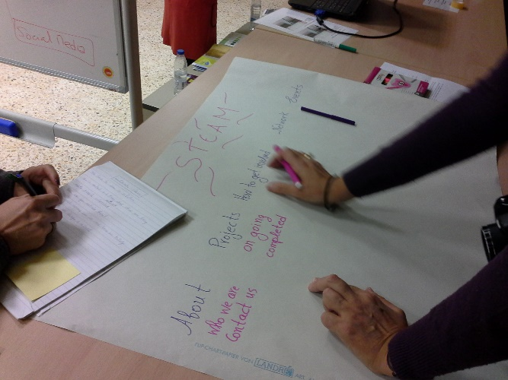
Figure 5.11 Cultivate Ideas (i)
Figure 5.12 Cultivate Ideas (ii)

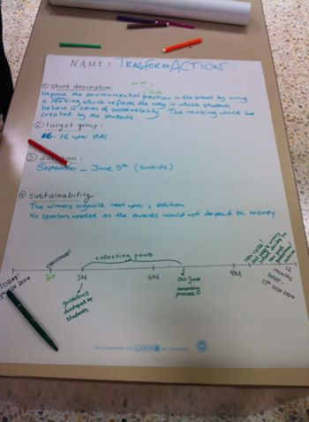
Figure 5.13 Cultivate Ideas (iii)
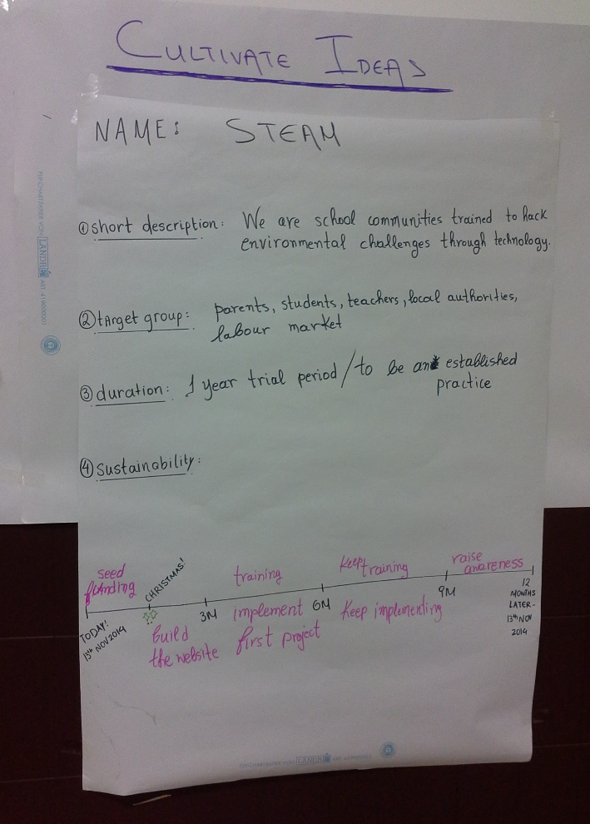
Figure 5.14 Cultivate Ideas (iv)

Blossom & Thrive
This was the final session of the workshop during which the two groups presented their projects and got feedback from each other in order to enhance and further develop them. The main issue extensively discussed at this stage was the sustainability prospects of each project.
First Group
STEAM
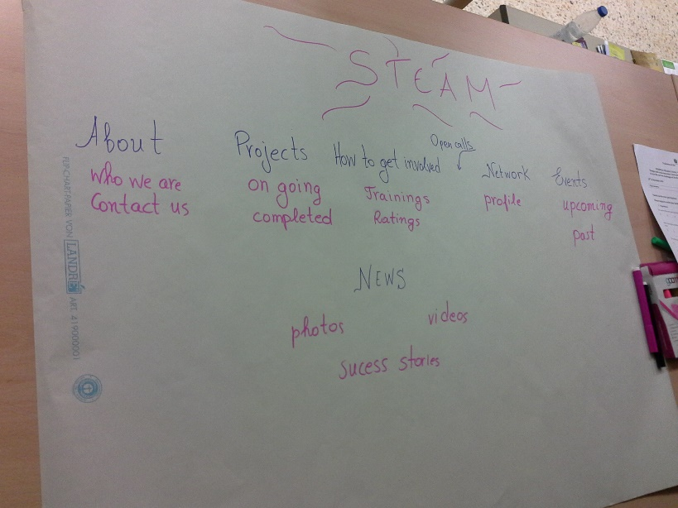
STEAM fosters the training of school communities (in this project school community includes parents) in environmental and scientific subjects in order to hack environmental problems that derive from the industrial or business world. STEAM provides the training for the skill building as well as the open calls from the industry. Each school community is rated according to the educational trainings they have completed in order to be eligible for the open calls. The prototype created by each community shall be used to solve the environmental problem of a business. As an example the group proposed the real case of a team of students that prototyped a robot that will transfer industrial waste from the factory to the recycling facility. This was considered by the participants as a methodology that covers a) the parents’ and teachers’ training b) increases the engagement of parents to joint activities as they face an immediate added value of the activity c) fosters volunteering d) provides intense degree of challenge for students e) cultivates entrepreneurship in a creative and knowledge-driven way while connects students directly with the green labour market.
Figure 5.15 Blossom & Thrive Phase (i)

The idea was video documented and further disseminated through:
http://youtu.be/XKq-mS-Fo_w

Second group
TransformACTION
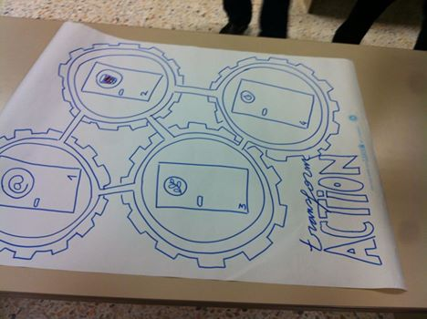
Green Way is an effective way to improve the environmental practices in the school by using a ranking plan, which reflects the way in which students behave in terms of sustainability. This is a long-term plan that involves yearly circles that are in the form of a competition between classes of one school. In order to decide on the initial ranking /scoring process, each class will propose one idea on how to be more environment-friendly and sustainable; the final plan will be based on the students’ votes. This voting process will lead to a concrete guide, fully explanatory of the different options for collecting points. At the end of a pre-specified period the class with more points will be voted by the winning class. The winners of this process will create their own plan for the next year’s competition. This activity was designed based on the participants’ voted notes; more specifically, the aim of this activity is to involve students in the design of the activity, to make them the protagonists of the educational activity from the early stages; also this activity aims to use project-based learning and links with real-life issues to help students adopt more environment-friendly approaches.
Figure 5.16 Blossom & Thrive Phase (ii)

The idea was video documented and further disseminated through:
http://youtu.be/O1hDYNEOnqE

Conclusions
The final outcomes of the ETW were the two educational activities described in chapter 5.4. Zooming into the specifics of each activity they have both answered successfully the challenges set at the beginning. Both groups were highly engaged and brought their personal experiences to the conversation. The participants analysed all possibilities and in the end attempted to design an educational activity that would best combine and address the most important points that surfaced during the workshop procedure. With this fact taken into account, as well as the fact that both activities qualify most of the Best Practice Criteria set by GreeNET, the workshop achieved its initial goals. The consortium was able to bring together teachers and policy makers and most importantly students and closely examine the good practices that can result from their collaboration.
In addition to the conclusions, the evaluation of the ETW by the participants provided the consortium with further information on its impact in order to refine the organisation and maximise the engagement for future applications of the methodology. The statistics presented in D5.5 Final Evaluation Report of GreeNET showed good impression and positive reaction overall.
The whole of the participants found the organisation and venue appropriate and felt really positive about the workshop atmosphere. However, the valuable information for this report lies in the content and results of the workshop. The content was considered well prepared, inspiring, interesting and clear to follow by the majority of the participants. Regarding the goals and outcomes of the workshop the statistics showed that participants appreciated the methodology, are willing to recommend a similar workshop and felt that they shared knowledge. They stated in the positives of the workshop that they had the chance to come up with new ideas and share experience and methodologies with teachers from other backgrounds both in terms of country and field of expertise. The participation of students was also warmly welcomed. A considerable amount of participants though, felt that the results and outcomes of the workshop were not of immediate use and felt that they did not have enough participation and interaction within their own group as well as with the other groups.
As a conclusion, the bigger picture of the workshop is positive and encourages to continue promoting design thinking workshops. Focusing on details, on future events smaller groups should be formed in order for all participants to have the opportunity to bring their ideas on the table and achieve stronger results of common work.

Annex I : List of Participants
Last Name | First Name | Profession/ Organization | Country
Group 1
- Galani | Aikaterini | Greek Research and Technology Network - GRNET | Greece
- Chioteli | Aikaterini | University Professor / Environmental Education Programmes Designer | Greece
- Plaza | Marta | Teacher / Barcelona School Agenda 21 | Spain
- Lloveras | Pere | Teacher / Barcelona School Agenda 21 | Spain
- Salvador | Gemma | Environmental researcher/Ecoinstitut | Spain
- Papakonstantinou | Aikaterini | Greek Research and Technology Network - GRNET | Greece
- Petridou | Varvara | Policy maker - Environmental education officer | Greece
- Sorko | Renata | Teacher Sciences and Public Health | Austria
- Härtel | Peter | Styrian Association for Education and Economics, Managing director | Austria
- Marterer | Michaela | Styrian Association for Education and Economics, Project manager | Austria
- Reinstadler | Gabriele | Bundesministerium für Unterricht, Kunst und Kultur (BM:UKK), Journalist | Austria
- Fernández | Rosanna | Teacher Technology / Cesire | Spain
- Castillón | Anna | Teacher Sciences / Cesire | Spain
- Regalés | Jordi | Teacher Technology / Cesire | Spain
Group 2
- Guitard | Lluís | Policy maker (Government of Catalonia) | Spain
- Azkarate | Elisabet | Teacher / Barcelona School Agenda 21 | Spain
- Sala | Lluís | Teacher / Barcelona School Agenda 21 | Spain
- Jarque | Pol | Student / Barcelona School Agenda 21 | Spain
- Guillem | Eduard | Student / Barcelona School Agenda 21 | Spain
- Manas | Anabel | Teacher / Barcelona School Agenda 21 | Spain
- Mercader | Natxo | Technician Barcelona School Agenda 21 | Spain
- Schaefer | Bettina | Environmental researcher/Ecoinstitut | Spain
- Naval | Sandra | Teacher (Professional Training of En. Education) | Spain
- Kalkani | Vassiliki | Economics/Business Teacher Ellinogermaniki Agogi | Greece
- Markaki | Vassiliki | Ellinogermaniki Agogi, Project manager | Greece
- Kontopoulou | Charitini | Agricultural University of Athens (AUA) | Greece
- Schönfelder | Mona | University of Bayreuth, Teacher Biology and Chemistry | Germany

Table 7.1 List of Participants

